CIS336: Lab 7 Answer Sheet

Your name Nathan Rivera

## Solution 1:

***~Paste your solution sql script here~***

lock table customers write;

set foreign_key_checks = 0;

alter table customers

modify customer_id integer auto_increment;

alter table customers modify customer_first_name varchar(20) null,

modify customer_last_name varchar(20) null,

modify customer_address varchar (50) null,

modify customer_city varchar(20) null,

modify customer_state char(2) null,

modify customer_zip char(5) null,

modify customer_phone char(10) null

;

insert into customers (customer_first_name, customer_last_name)

values ("Nathan", "Rivera"),

("thom", "something");

select * from customers;

***~Paste your solution query results text here~***

|  |  |  |  |  |  |
| --- | --- | --- | --- | --- | --- |
| 3 | 6 | 18:40:33 | select * from customers LIMIT 0, 1000 | 33 row(s) returned | 0.000 sec / 0.000 sec |

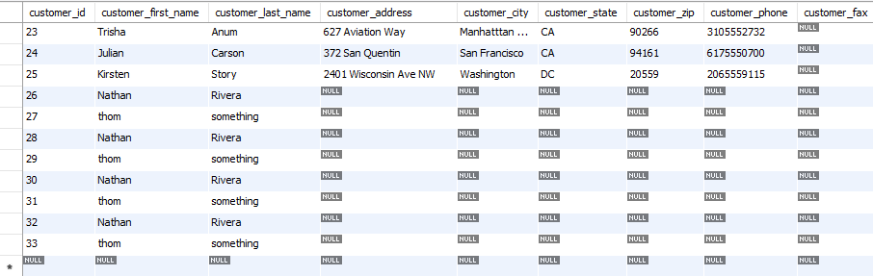

## Solution 2:

***~Paste your solution sql script here~***

-- 2

unlock tables;

SET SQL_SAFE_UPDATES = 0;

drop view if exists CA_CUSTOMERS;

create view CA_CUSTOMERS as

select * from customers

where customer_state = "CA";

update CA_CUSTOMERS

set customer_last_name = 'Lacie'

where customer_last_name = 'Lacy';

select * from CA_CUSTOMERS;

***~Paste your solution query results text here~***

|  |  |  |  |  |  |
| --- | --- | --- | --- | --- | --- |
| 3 | 35 | 19:12:49 | select * from view_test LIMIT 0, 1000 | 11 row(s) returned | 0.000 sec / 0.000 sec |

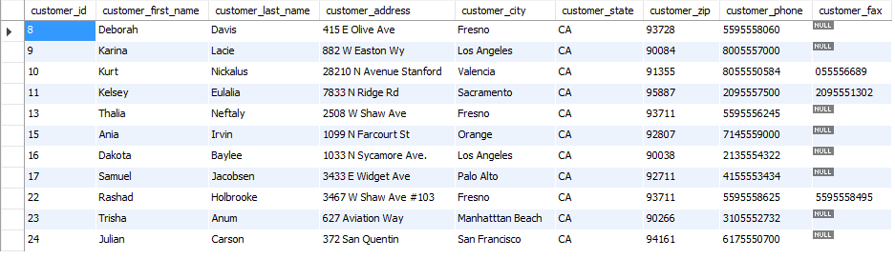

------------------------------------------------------------------------------------------------------------------------------------------



## Solution 3:

***~Paste your solution sql script here~***

-- 3

unlock tables;

drop view if exists SHIPPING_TIME;

create view SHIPPING_TIME as

select customers.customer_first_name, customers.customer_last_name, orders.order_date, orders.shipped_date, datediff(orders.shipped_date, orders.order_date) as days_to_fulfill

from customers

join orders

on orders.customer_id = customers.customer_id;

select * from SHIPPING_TIME

order by days_to_fulfill desc;

select * from shipping_time

where days_to_fulfill < 10;

select * from shipping_time

where days_to_fulfill > 30;

***~Paste your solution query results text here~***

|  |  |  |  |  |  |
| --- | --- | --- | --- | --- | --- |
| 3 | 4 | 19:45:46 | select * from SHIPPING_TIME order by days_to_fulfill desc LIMIT 0, 1000 | 42 row(s) returned | 0.000 sec / 0.000 sec |
| 3 | 5 | 19:45:46 | select * from shipping_time where days_to_fulfill < 10 LIMIT 0, 1000 | 24 row(s) returned | 0.000 sec / 0.000 sec |
| 3 | 6 | 19:45:46 | select * from shipping_time where days_to_fulfill > 30 LIMIT 0, 1000 | 4 row(s) returned | 0.000 sec / 0.000 sec |

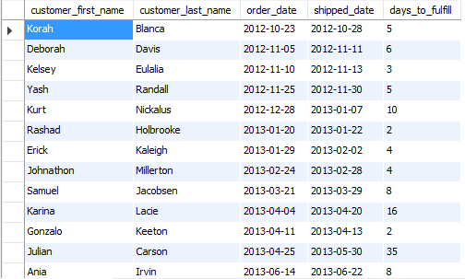

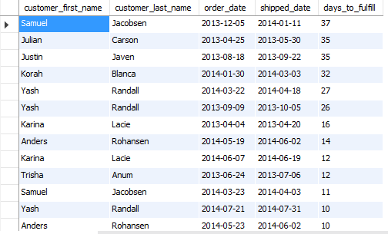

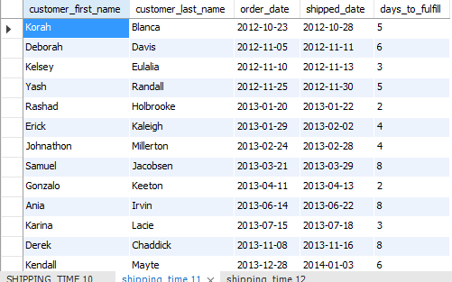

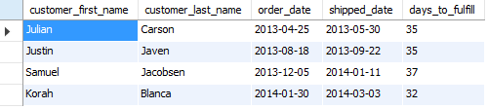

## Solution 4:

***~Paste your solution sql script here~***

***~Paste your solution query results text here~***

## Solution 5:

***~Paste your solution sql script here~***

***~Paste your solution query results text here~***